LINUX ENVIRONMENT VARIABLES

1. State the command for the following.
   1. view current environment variables

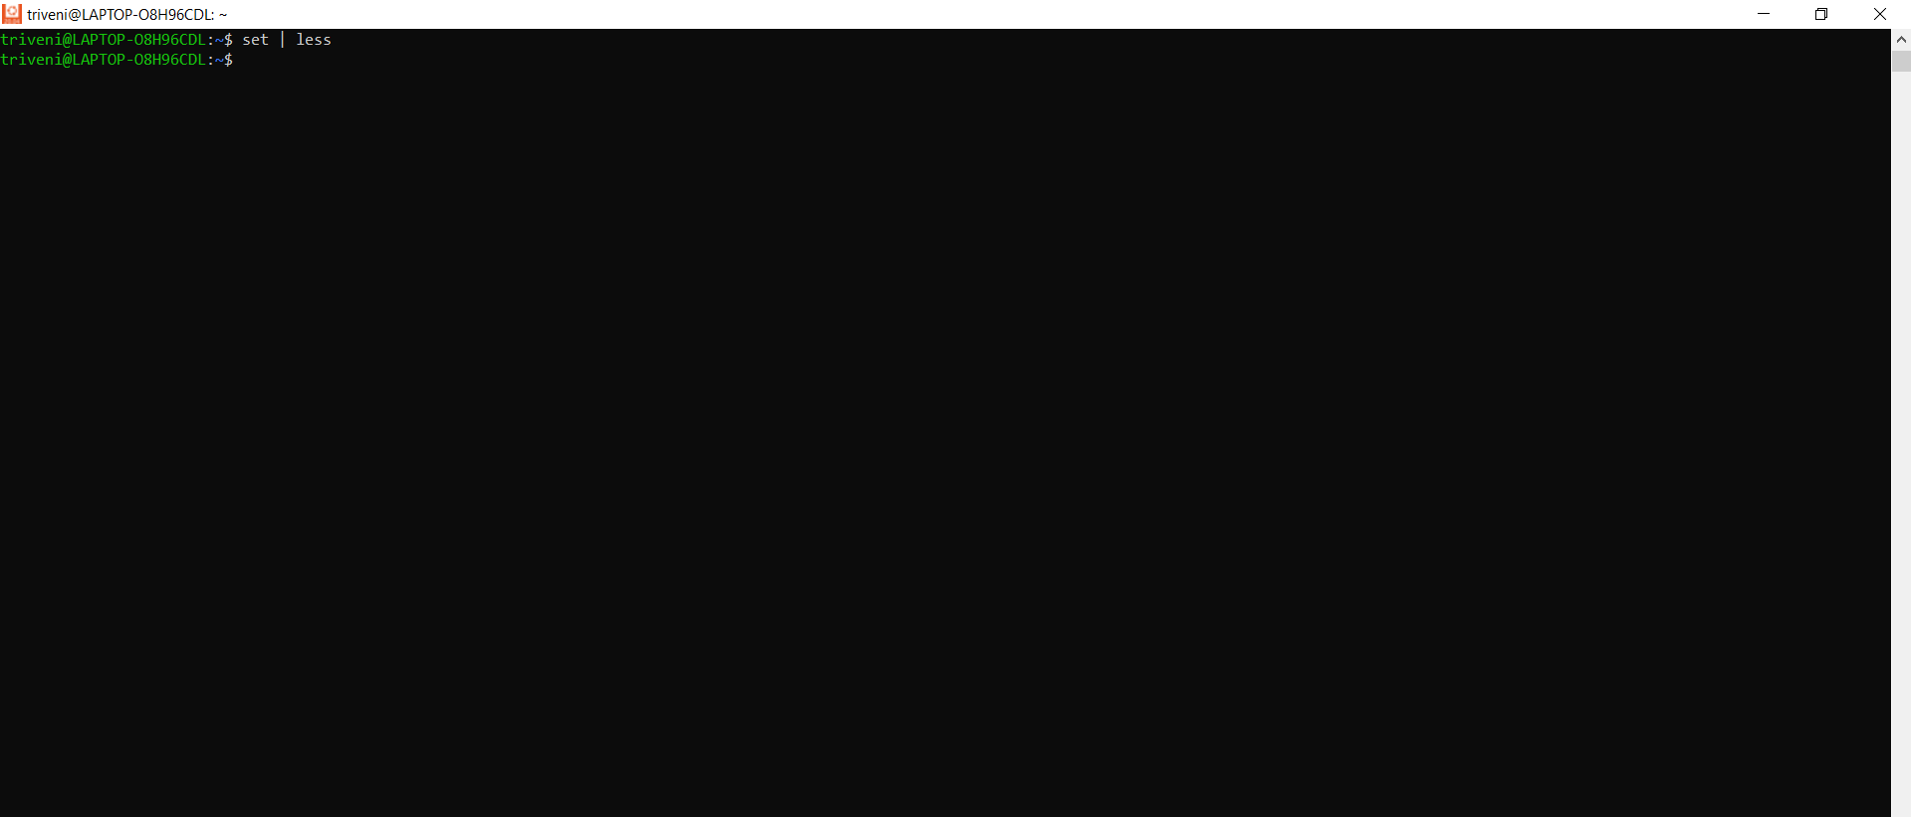

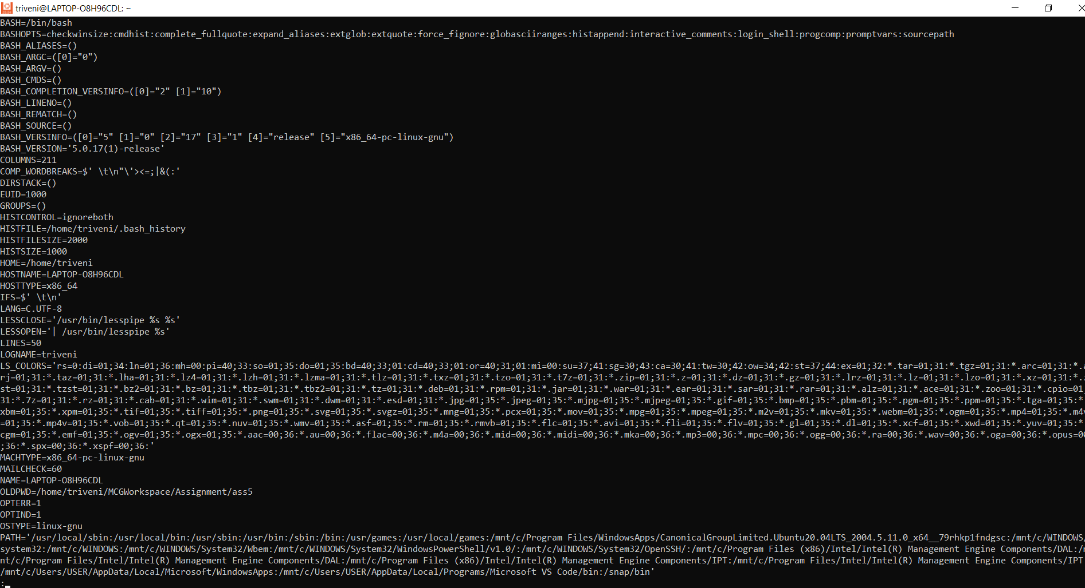

* 1. Display the PATH environment variable value
  2. update PATH to include the path to your home directory

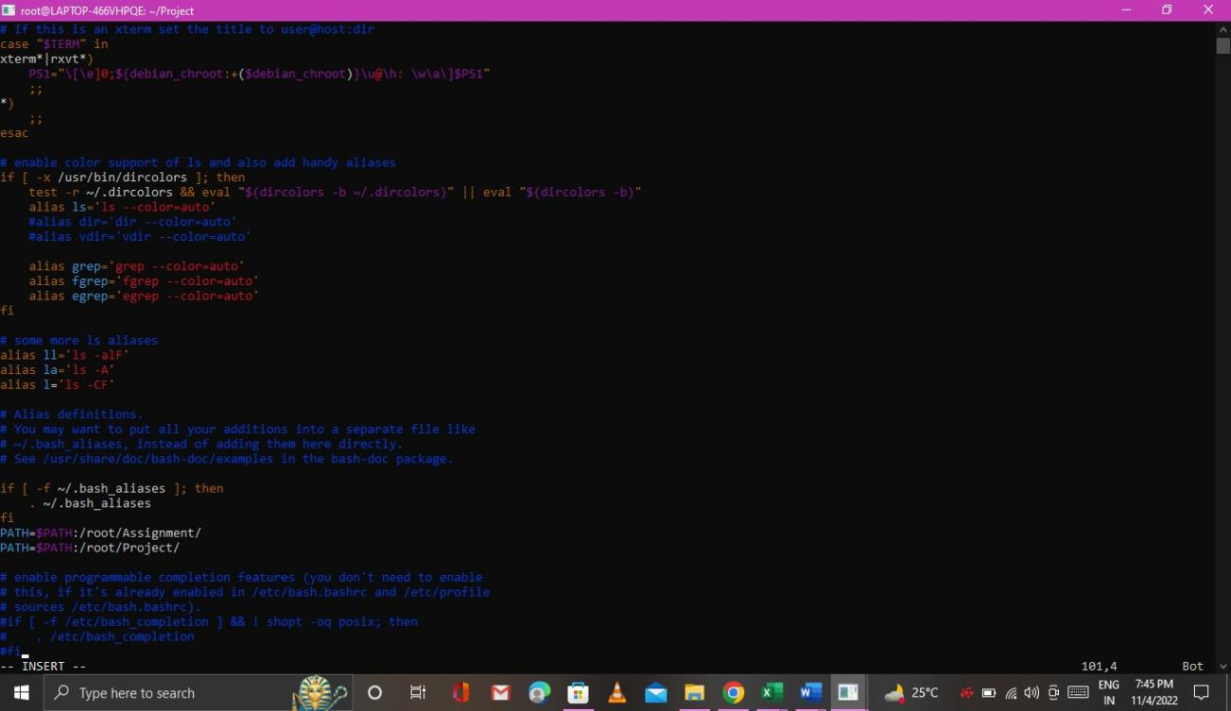

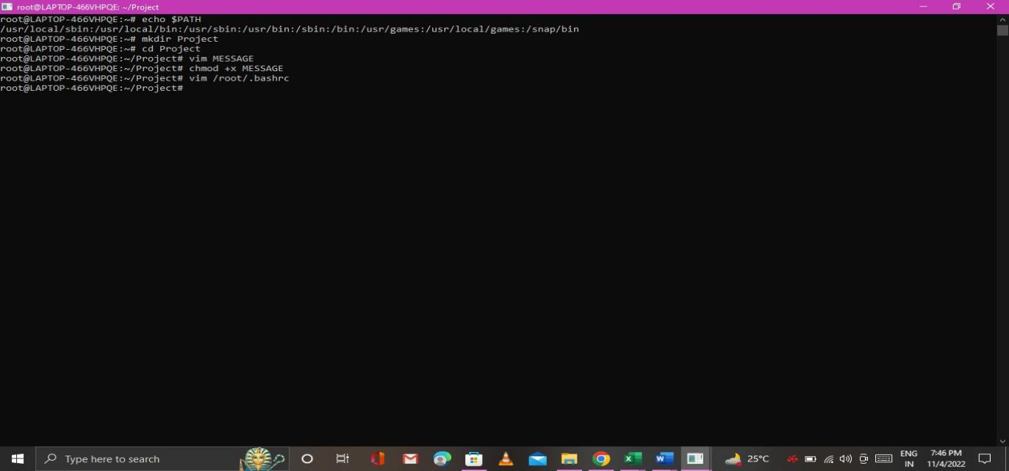

1. How will you make the environment changes applicable to all users? Which script is to be modified?

Ans. To make the environment changes applicable to all users, go to your /etc/skel files, such as . bashrc , and change the ones that are already there or enter the new ones. When you create new users, these /etc/skel files will be copied to the new user’s home directory.